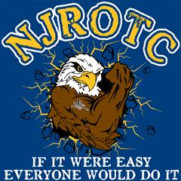
Eagles Landing High School
Navy Junior Reserve Officers Training Corps

Personal Appearance and Grooming Standard

I understand that the uniform I have been issued are regulation U.S. Navy uniform items and as such, when worn, represent the reputation of the men and women who wear them so proudly in the defense of our country. I pledge never to tarnish this proud reputation by wearing my uniform in a manner that would bring discredit or embarrassment to the unit or the U.S. Navy.

I understand the requirement to wear my uniform once a week (normally on Thursday) and that it must be dry clean regularly and worn clean and neatly pressed. I further understand the requirement to abide by the grooming standards, in and out of uniform, as set forth in Chapter One of the Navy Junior Reserve Officer Training Corps’ Cadet Field Manual (Orange Book).

Finally, I understand that failure to adhere to these standards and requirement will result in a failing grade for my weekly inspection and may jeopardize my chances of promotion and continuation in the NJROTC program.

_____________________________ ____________________________
PRINT Cadet’s Full Name PRINT Parent/Guardian Name

___________________________________ __________________________________
Cadet’s Signature Parent/Guardian’s Signature

Uniform Certification

I accept responsibility for the clothing items issued to my son/daughter/ward. I understand that they are the property of the U.S. Government and they are to be returned to the Navy Unit dry cleaned and good condition, I voluntarily agree to reimburse the U.S. Government for the value of any such items, which may be dirty, lost or mutilated through misconduct or carelessness.

_____________________ ______________________________
Date Cadet’s Signature

_____________________ ______________________________
Date Parent/Guardian Signature

